**MUSIC STORE**

**Created by : Vaibhav Rohidas Kamble.**

**Contact no : +91 9890969840**

**Email : vaibhavrk017@gmail.com**

In this document, we have saved the different queries used in SQL to solve the music store dataset problem statement.

Which includes CTE, Recursive CTE, Joins, and Sub-Queries.

**SECTION 1 : EASY QUESTIONS**

1. Who is the senior most employee based on job title?

select first_name, last_name, title as job_title, levels

from employee

order by levels desc limit 1;



1. What are the job titles offered in this dataset?

select title as job_title, count(*) as job_count, levels

from employee

group by 1,3

order by 3 desc;

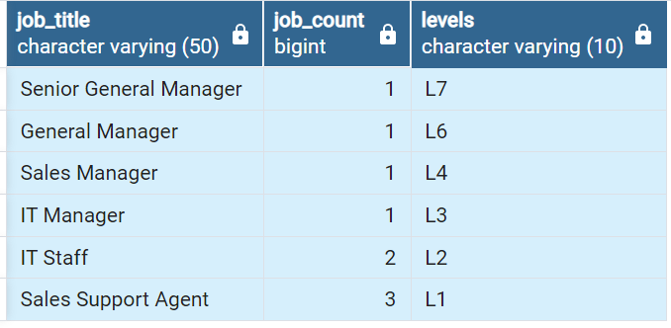

1. Top 10 countries having the most Invoices?

select * from invoice;

select count(*) as count, billing_country

from invoice

group by billing_country

order by count desc limit 10;

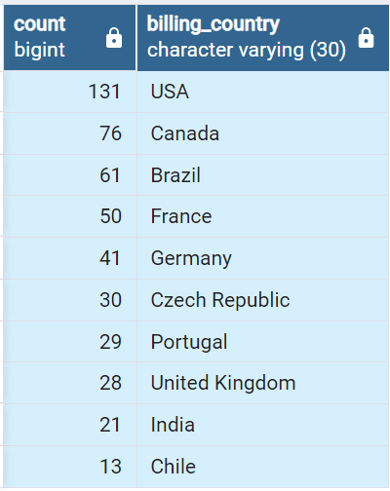

1. what are the top 3 values of invoices?

select * from invoice

order by total desc limit 3;

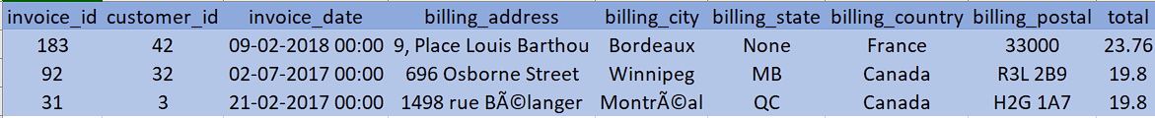

1. Which city has the best customers?

we would like to through the promotional music festival in the city where we made the most money. write a query that returns one city that has the highest sum of invoice totals. return both the city name and the sum of all invoice totals.

select billing_city, sum(total) as invoice_total

from invoice

group by billing_city

order by invoice_total desc limit 1;

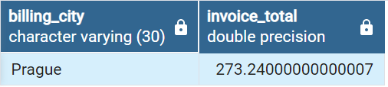

1. Who is the best customer?

The customer who has spent the most money will be declared the best customer. Write the query that returns the person who has spent the most money.

select c.first_name, c.last_name, i.billing_city, sum(i.total) as invoice_total

from customer c

left join invoice i on i.customer_id = c.customer_id

group by first_name, last_name, billing_city

order by invoice_total desc limit 1;

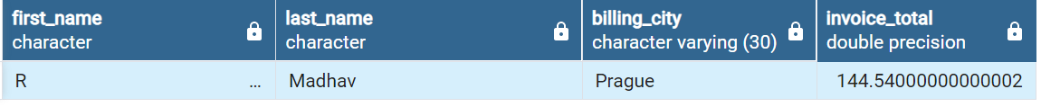

**SECTION 2 : MODERATE QUESTIONS**

1. Write a query to return the email, first name, last name, and genre of all rock music listeners

return your list ordered alphabetically by email starting with A.

select * from customer;

select c.first_name, c.last_name, c.email, g.name

from customer c

join invoice i on c.customer_id = i.customer_id

join invoice_line il on il.invoice_id = i.invoice_id

join track t on t.track_id = il.track_id

join genre g on g.genre_id = t.genre_id

group by c.first_name, c.last_name, c.email, g.name

having g.name like 'Rock'

order by c.email asc;

* same question using subquery / Query optimization:

select c.email, c.first_name, c.last_name

from customer c

join invoice i on i.customer_id = c.customer_id

join invoice_line il on il.invoice_id = i.invoice_id

where track_id in (select track_id

from track t

join genre g on t.genre_id = g.genre_id

where g.name like 'Rock')

order by email;

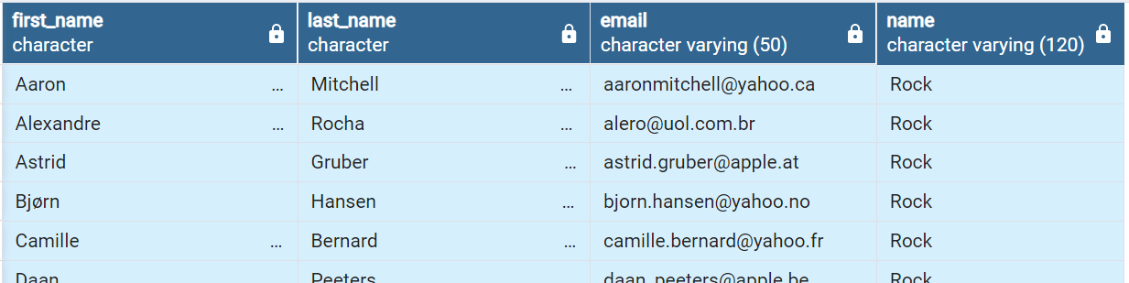

1. Let's invite the artists who have written the most rock music in our dataset. Write the query that returns the artist name and total track count of the top 10 rock bands.

select a.artist_id, a.name, count(t.name) as track_count

from artist a

join album m on a.artist_id = m.artist_id

join track t on m.album_id = t.album_id

join genre g on g.genre_id = t.genre_id

where g.name like 'Rock'

group by a.artist_id, a.name

order by track_count desc limit 10;

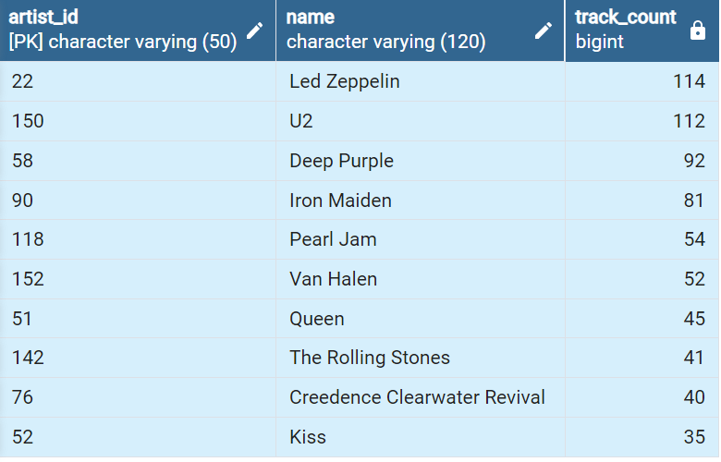

1. Written all the track names that have song lengths longer than the average song length.

Return the Name and Milliseconds for each track. Order by the song length with the longest

songs listed first.

select name, milliseconds

from track

where milliseconds > (

select avg(milliseconds) as avg_song_length

from track)

order by milliseconds desc;

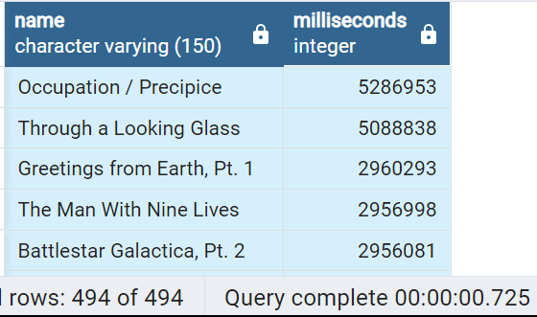

**SECTION 3 : CTE - ADVANCED QUESTIONS**

1. Find how much amount spent by each customer on artists? Write a query to return the customer

name, artist name, and total spend.

with best_selling_artist as(

select a.artist_id, a.name as artist_name,

sum(il.unit_price*il.quantity) as total_sales

from invoice_line il

join track t on t.track_id = il.track_id

join album on album.album_id = t.album_id

join artist a on a.artist_id = album.artist_id

group by 1

order by 3 desc limit 1

)

select c.customer_id, c.first_name, c.last_name,bsa.artist_name,

sum(il.unit_price*il.quantity) as total_spend

from invoice i

join customer c on c.customer_id = i.customer_id

join invoice_line il on il.invoice_id = i.invoice_id

join track t on t.track_id = il.track_id

join album on album.album_id = t.album_id

join best_selling_artist bsa on bsa.artist_id = album.artist_id

group by 1,2,3,4

order by 5 desc;

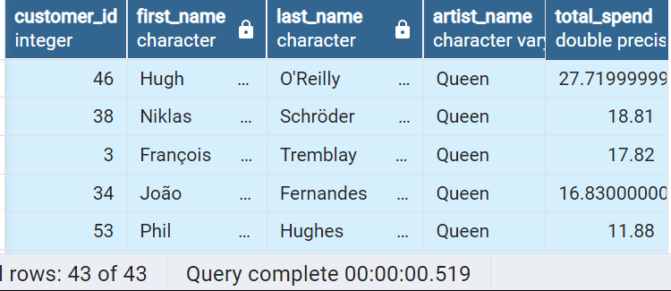

1. We want to find out the most popular music genre for each country. We determine the most

popular genre as the genre with the highest amount of purchases. Write a query that returns

each country along with the top genre for the country where a maximum number of purchases is shared

and returns all genres.

* Method 1: using CTE

with popular_genre as

( select count(il.quantity) as purchases, c.country, g.name as genre_name, g.genre_id,

row_number() over(partition by c.country order by count(il.quantity) desc) as row_number

from invoice_line il

join invoice i on i.invoice_id = il.invoice_id

join customer c on c.customer_id = i.customer_id

join track t on t.track_id = il.track_id

join genre g on g.genre_id = t.genre_id

group by 2,3,4

order by 2 asc, 1 desc

)

select * from popular_genre where row_number <= 1 order by purchases desc;

* Method 2: using recursive CTE

with recursive

sales_per_country as(

select count(*) as purchase_per_genre, c.country, g.name as genre_name, g.genre_id

from invoice_line il

join invoice i on i.invoice_id = il.invoice_id

join customer c on c.customer_id = i.customer_id

join track t on t.track_id = il.track_id

join genre g on g.genre_id = t.genre_id

group by 2,3,4

order by 2 asc

),

max_genre_per_country as (select max(purchase_per_genre) as max_genre_number, country

from sales_per_country

group by 2

order by 2)

select sales_per_country.*

from sales_per_country

join max_genre_per_country on max_genre_per_country.country = sales_per_country.country

where sales_per_country.purchase_per_genre = max_genre_per_country.max_genre_number;

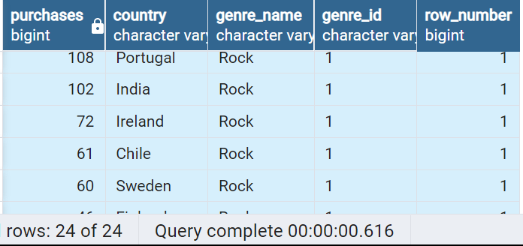

1. Write a query that determines the customer that has spent the most on music for each country.

Write a query that returns the country along with the customers and how much they spent. for countries

where the top amount spent is shared, provide all customers who spent this amount.

* Method 1: Using Recursive CTE

with recursive

customer_with_country as(

select c.customer_id, c.first_name, c.last_name, i.billing_country, sum(i.total) as total_spending

from invoice i

join customer c on c.customer_id = i.customer_id

group by 1,2,3,4

order by 2,3 desc),

country_max_spending as(

select max(total_spending) as max_spending, billing_country

from customer_with_country

group by billing_country)

select cc.first_name, cc.last_name, cc.billing_country, cc.total_spending, cc.customer_id

from customer_with_country cc

join country_max_spending ms on cc.billing_country = ms.billing_country

where cc.total_spending = ms.max_spending

order by 3;

* Method 2: Using CTE

with customer_with_country as(

select c.customer_id, first_name, last_name, billing_country, sum(total) as total_spending,

row_number() over(partition by billing_country order by sum(total) desc ) as row_number

from invoice i

join customer c on c.customer_id = i.customer_id

group by 1,2,3,4

order by 4 asc, 5 desc)

select * from customer_with_country where row_number <= 1;

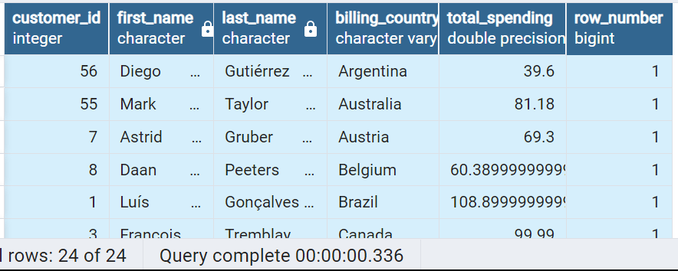

**Keep Learning New Things 😊**